Final Concentrations Database!

By Thomas P McGuire

**Summary:**

To construct a database of concentrations for various final products that are manufactured. My current role dictates that I find the final concentrations of these materials. Different final products have different ranges in concentrations and concentration is a release criteria. If it is not within concentration, it cannot move forward.

**Business rules:**

One or more operators can run any sample.The sample can be run on one or more instruments. Instruments need to have preventative maintenance done every 12 months or they cannot be used to run samples. Each instrument is identified by an unique ID. Samples have a date run, a batch ID that is unique, a material name, a final concentration, lower concentration limit and upper concentration limit along with a sample status.

**Data Questions:**  
Which operator is the most consistent in analyzing the concentrations across the instruments?

Which products are the closest to the upper and lower limits?

How much variability is there between instruments?

Is there much variability between operators?

How are the number of samples split between operators?

**Stakeholders:**

My department, Quality Operations and the department that gives us the product to test, Manufacturing of Critical Materials. If the product fails the concentration by being too concentrated or not concentrated enough, time and money are wasted either disposing of the product and remaking it or by reprocessing. There also needs to be an investigation, which would involve a third department, who would investigate why the product was not within concentration. Creating this database and then trending the data could give us insight into which of the products is troublesome.

**Expectations:**

The expectations for this database are to keep track of the sample and their associated results so that they can be trended and any potential issues be identified. The products that are run can be compared to the historical data to check for consistency across instruments and operators as well as future data.

**Conceptual Model:**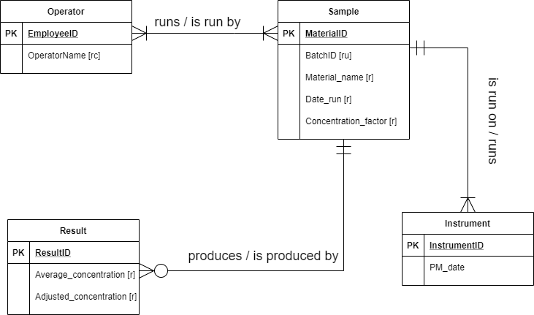

**Logical Model:**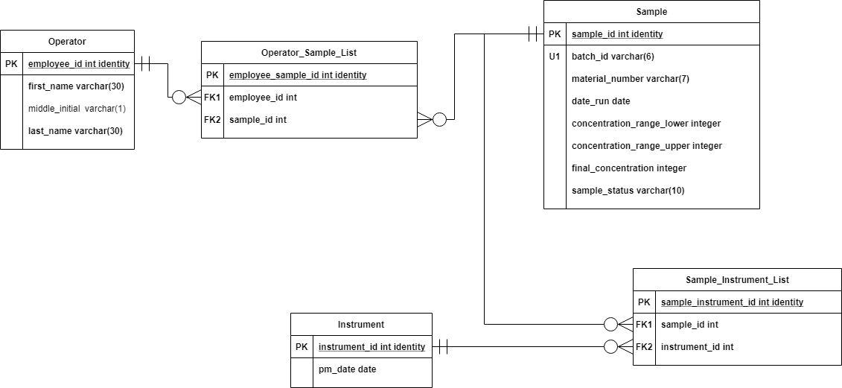

**Physical Database Design:**

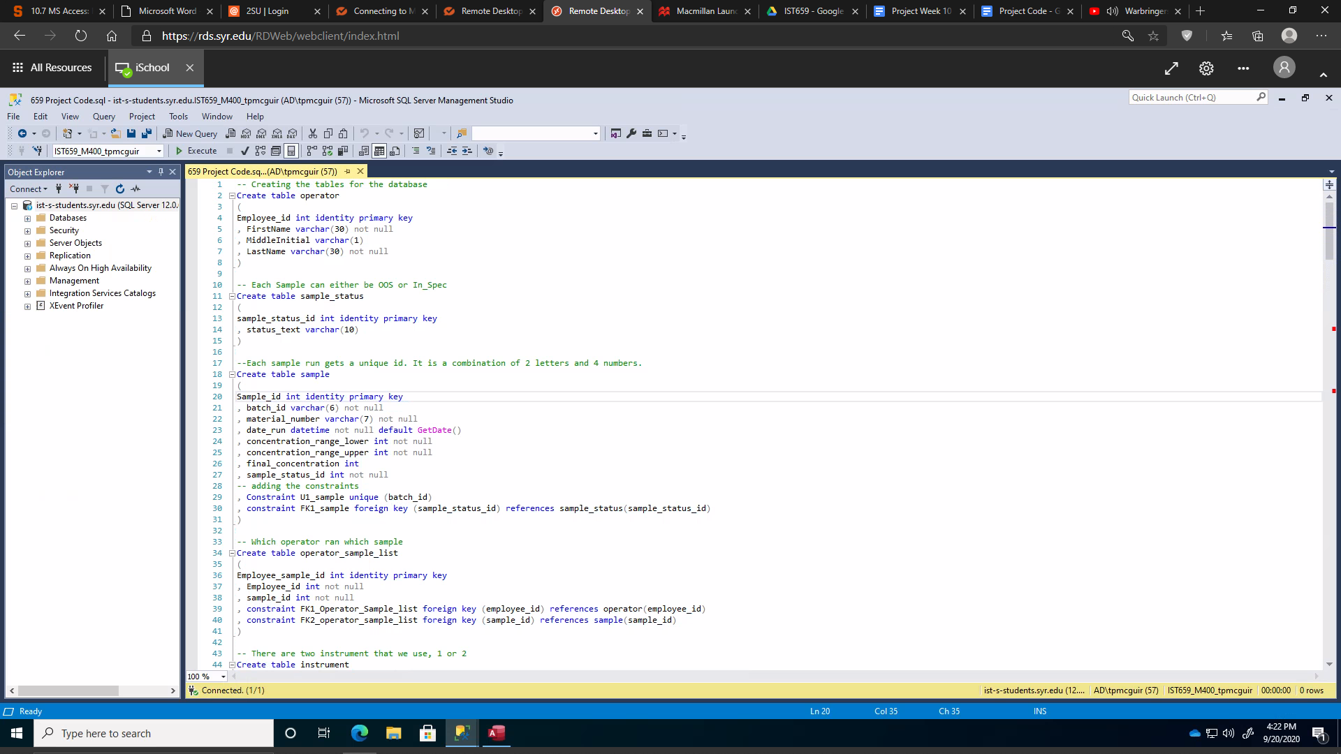

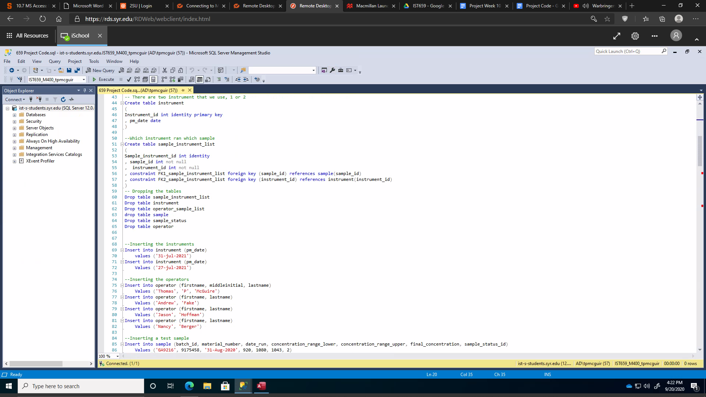

-- Creating the tables for the database

Create table operator

(

Employee_id int identity primary key

, FirstName varchar(30) not null

, MiddleInitial varchar(1)

, LastName varchar(30) not null

)

-- Each Sample can either be OOS or In_Spec

Create table sample_status

(

sample_status_id int identity primary key

, status_text varchar(10)

)

--Each sample run gets a unique id. It is a combination of 2 letters and 4 numbers.

Create table sample

(

Sample_id int identity primary key

, batch_id varchar(6) not null

, material_number varchar(7) not null

, date_run datetime not null default GetDate()

, concentration_range_lower int not null

, concentration_range_upper int not null

, final_concentration int

, sample_status_id int not null

-- adding the constraints

, Constraint U1_sample unique (batch_id)

, constraint FK1_sample foreign key (sample_status_id) references sample_status(sample_status_id)

)

-- Which operator ran which sample

Create table operator_sample_list

(

Employee_sample_id int identity primary key

, Employee_id int not null

, sample_id int not null

, constraint FK1_Operator_Sample_list foreign key (employee_id) references operator(employee_id)

, constraint FK2_operator_sample_list foreign key (sample_id) references sample(sample_id)

)

-- There are two instrument that we use, 1 or 2

Create table instrument

(

Instrument_id int identity primary key

, pm_date date

)

--Which instrument ran which sample

Create table sample_instrument_list

(

Sample_instrument_id int identity

, sample_id int not null

, instrument_id int not null

, constraint FK1_sample_instrument_list foreign key (sample_id) references sample(sample_id)

, constraint FK2_sample_instrument_list foreign key (instrument_id) references instrument(instrument_id)

)

-- Dropping the tables in the correct order

Drop table sample_instrument_list

Drop table instrument

Drop table operator_sample_list

drop table sample

Drop table sample_status

Drop table operator

**Data Creation:**

--Inserting the instruments

Insert into instrument (pm_date)

values ('31-jul-2021')

Insert into instrument (pm_date)

Values ('27-jul-2021')

--Inserting the operators

Insert into operator (firstname, middleinitial, lastname)

Values ('Thomas', 'P', 'McGuire')

Insert into operator (firstname, lastname)

Values ('Andrew', 'Fake')

Insert into operator (firstname, lastname)

Values ('Jason', 'Hoffman')

Insert into operator (firstname, lastname)

Values ('Nancy', 'Berger')

--Inserting a test sample

Insert into sample (batch_id, material_number, date_run, concentration_range_lower, concentration_range_upper, final_concentration, sample_status_id)

Values ('GA9216', 9175458, '31-Aug-2020', 920, 1080, 1043, 2)

--Inserting sample_status

Insert into sample_status (status_text)

Values ('OOS')

Insert into sample_status (status_text)

Values ('In_Spec')

-- Creating a stored procedure to add samples more efficiently

Alter procedure spAddSample(

@batch varchar(6)

, @materialnum varchar(7)

, @crl int

, @cru int

, @final int

) AS

Begin

Insert into sample (batch_id, material_number, date_run, concentration_range_lower, concentration_range_upper, final_concentration, sample_status_id)

Values (

@batch, @materialnum, GETDATE(), @crl, @cru, @final, 2

)

Return @@identity

End

-- Creating a stored procedure to assign operators to a sample

Create procedure spAddOperatorSample(

@employee int

, @sample int

) AS

Begin

Insert into operator_sample_list (employee_id, sample_id)

Values (

@employee, @sample

)

Return @@identity

END

-- Creating a stored procedure to assign an instrument to each sample

Create procedure spAddInstrumentSample(

@sample int

, @instrument int

) AS

Begin

Insert into sample_instrument_list (sample_id, instrument_id)

Values (

@sample, @instrument

)

Return @@identity

END

**Data Manipulation:**

--Updating the concentration range to increase the acceptable bounds

Update sample

Set concentration_range_lower = 200-16, concentration_range_upper = 200+16

Where material_number = 7007523

-- Checking for any samples that are are OOS

Update sample

Set sample_status_id = 1

Where final_concentration < concentration_range_lower OR final_concentration > concentration_range_upper

**Answering the Data Questions:**

Which operator is the most consistent in analyzing the concentrations across the instruments?

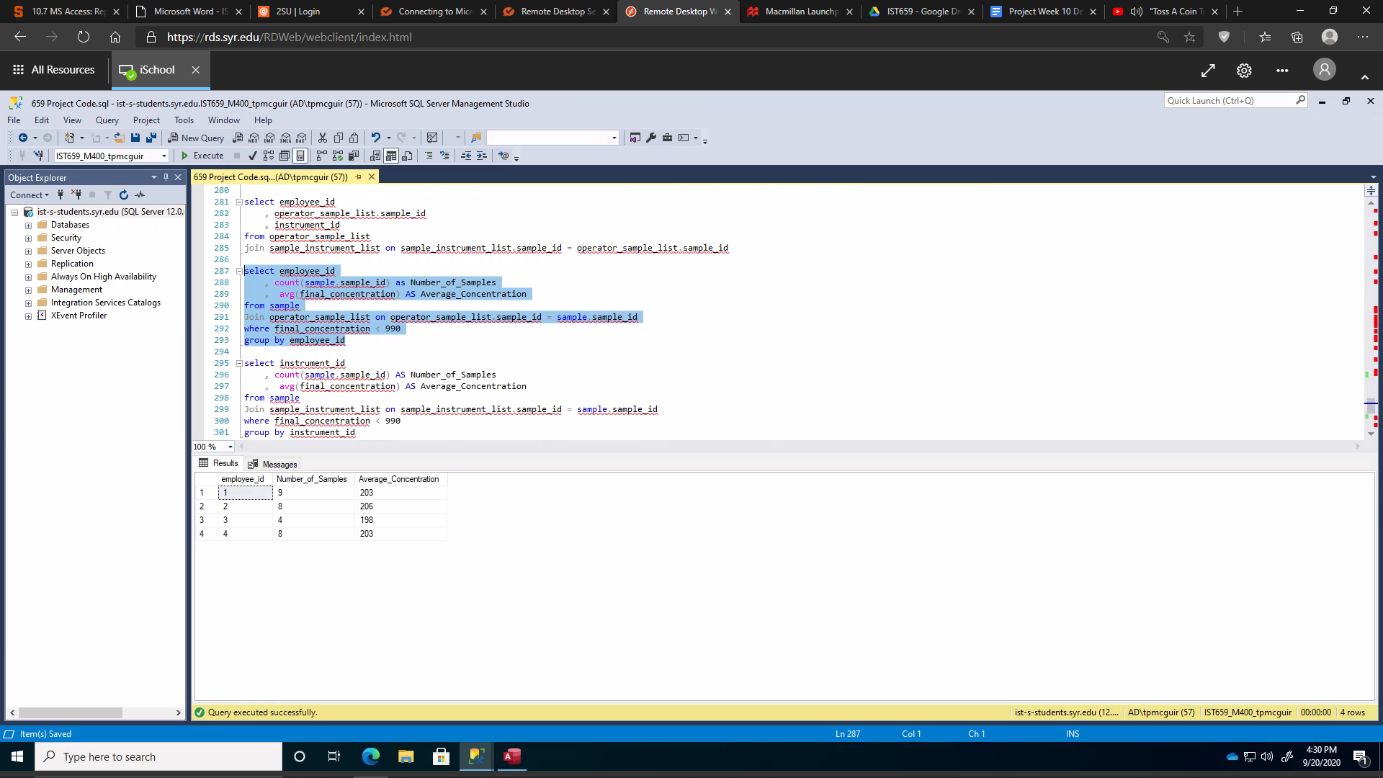

How much variability is there between instruments?

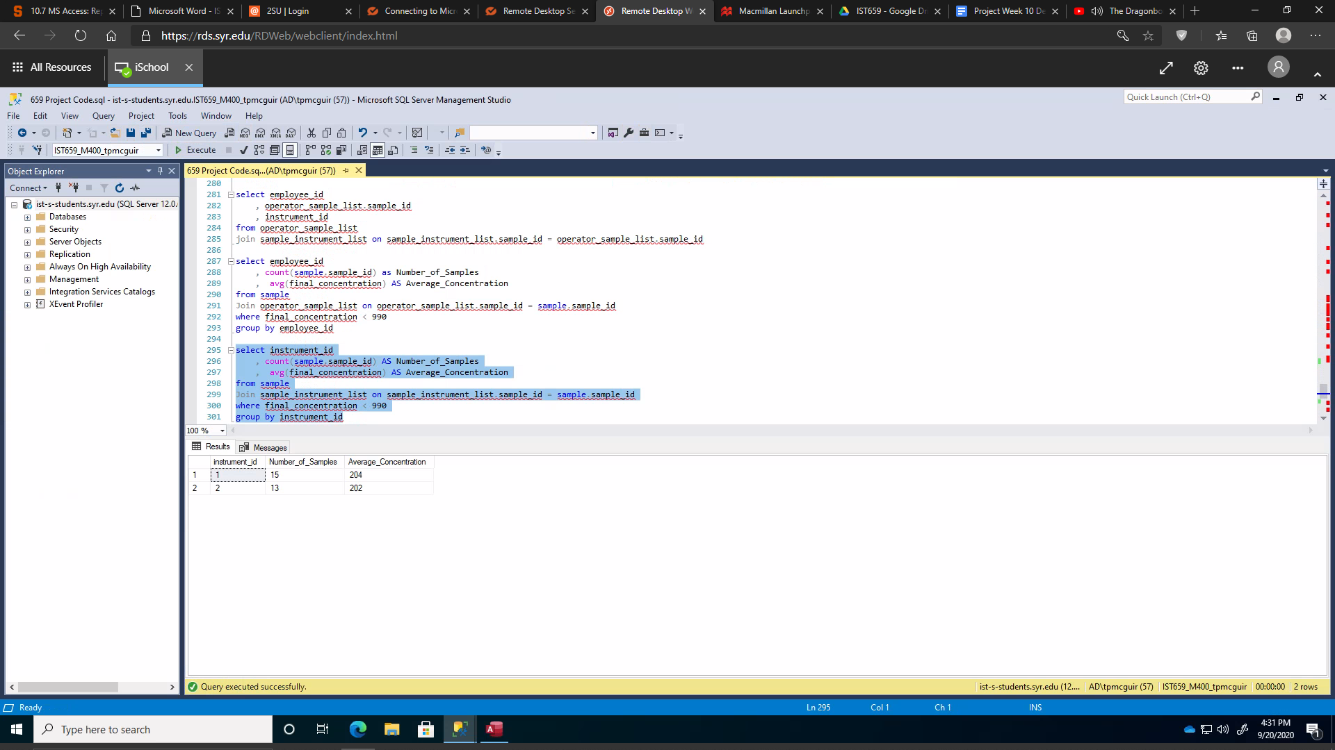

Is there much variability between operators?

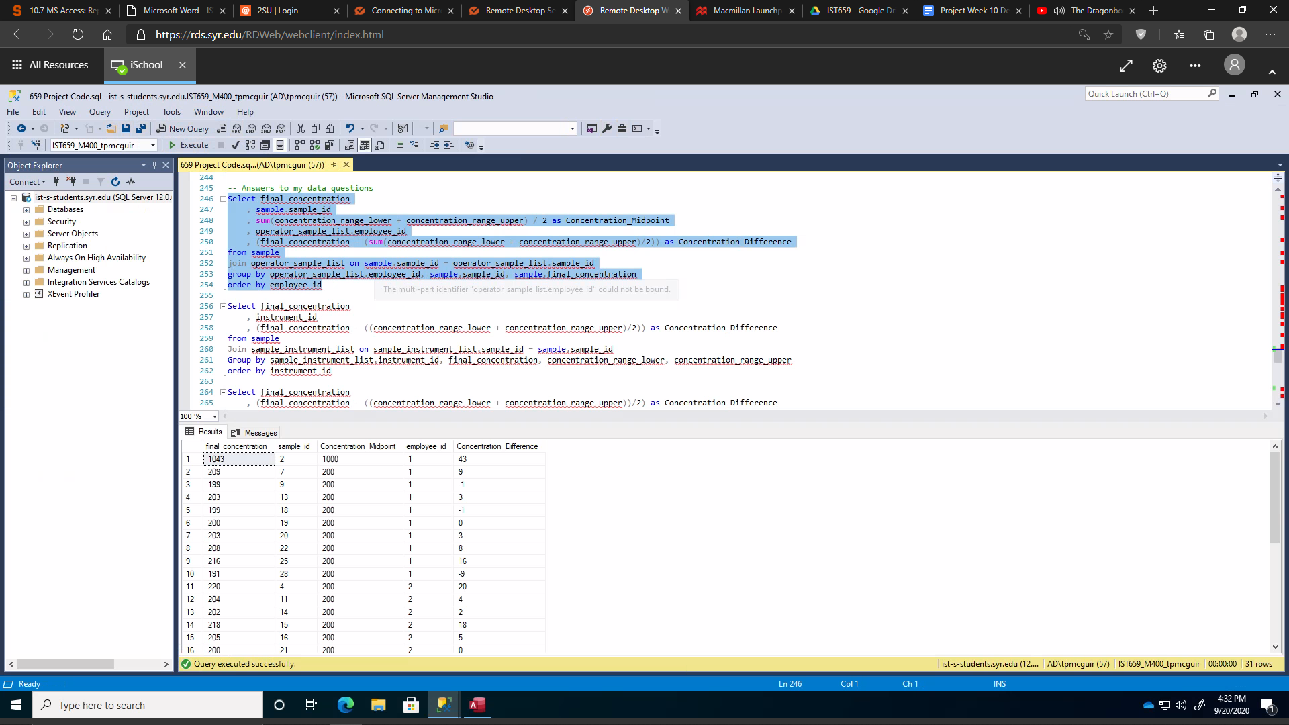

How are the number of samples split between operators?

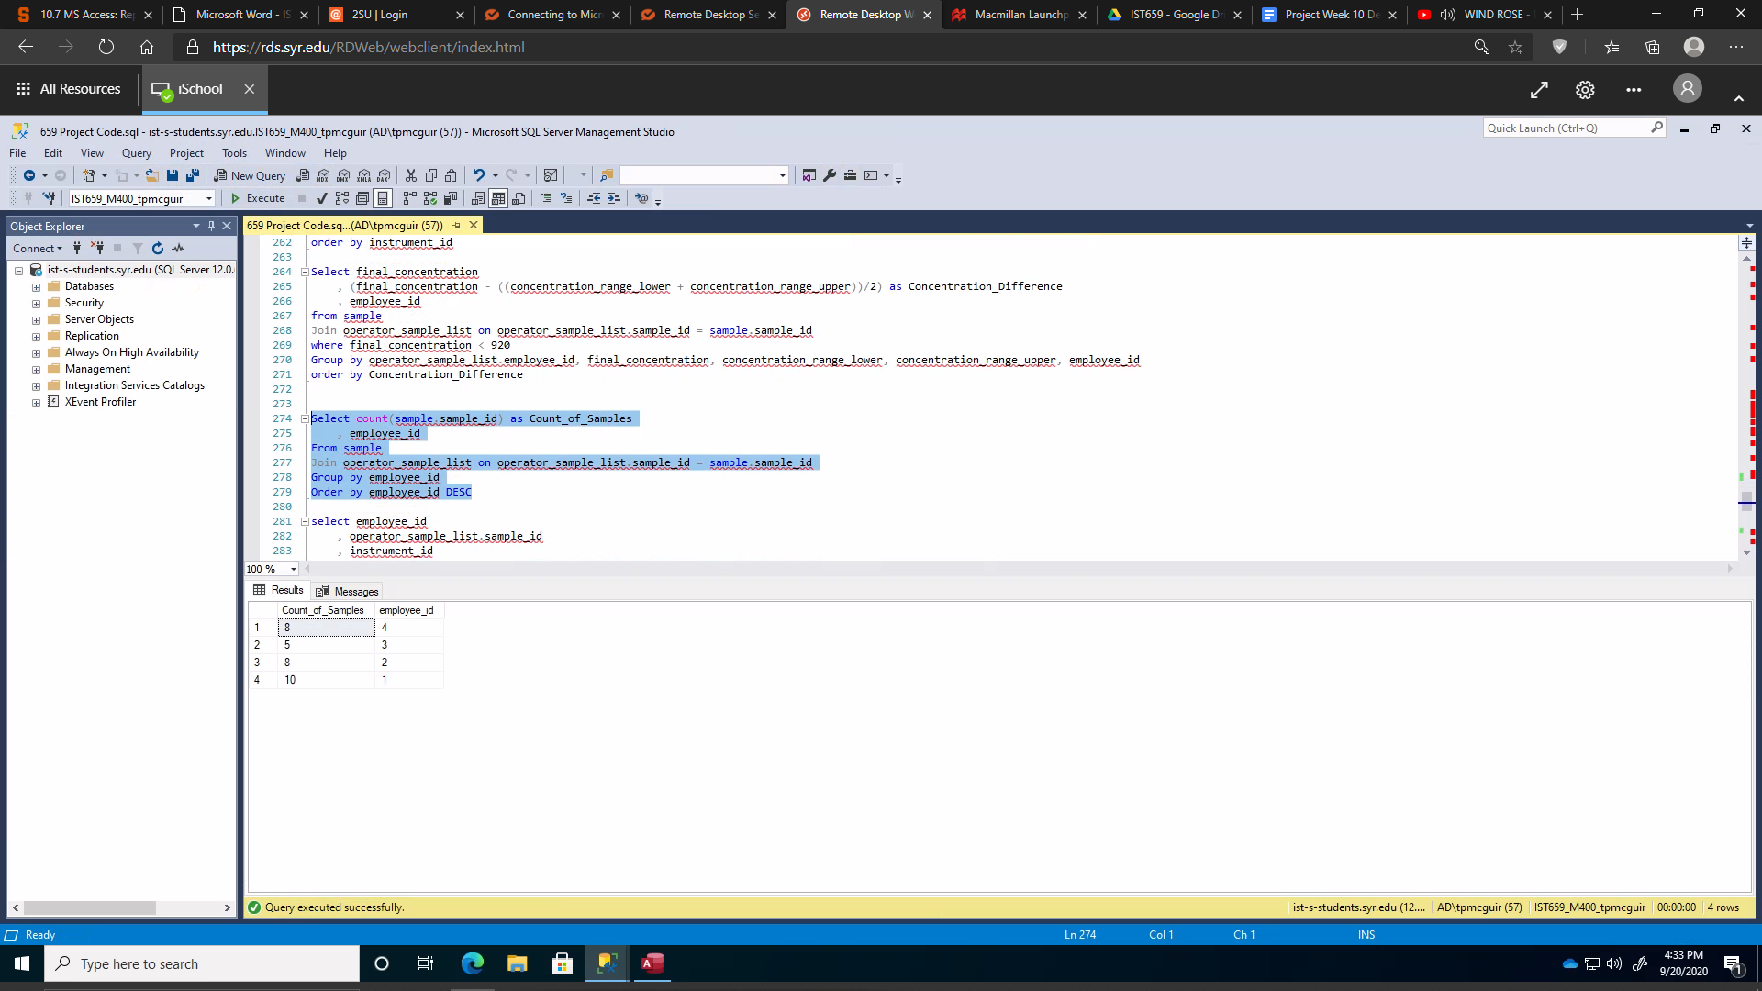

With a view!

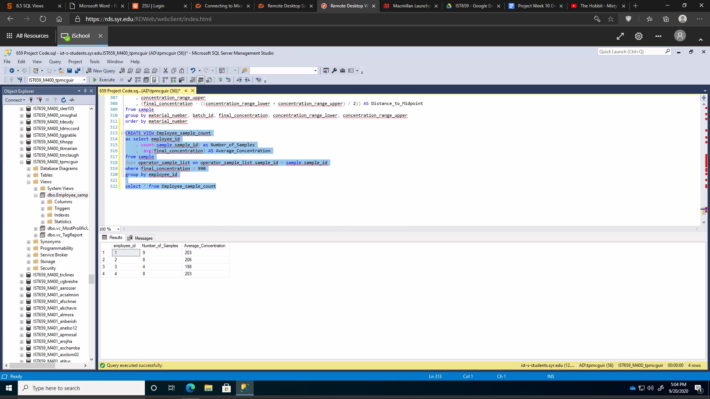

Which products are the closest to the upper and lower limits?

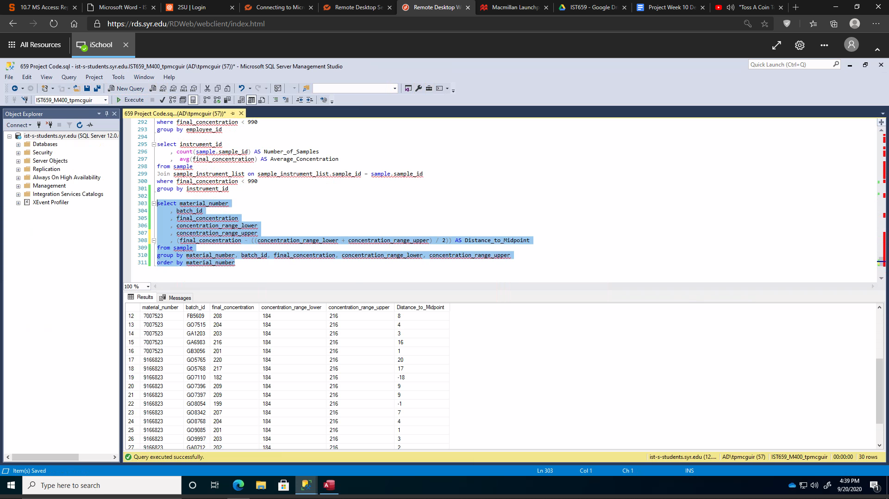

With a view!

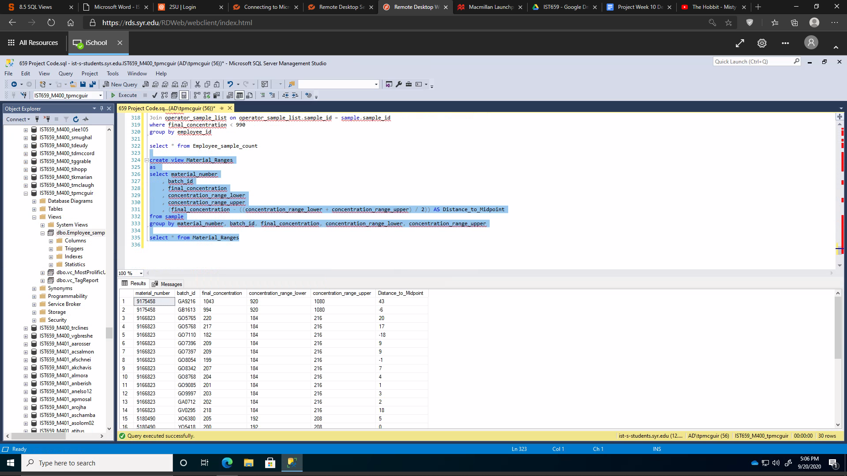

**Implementation:**

Add Additional Samples:

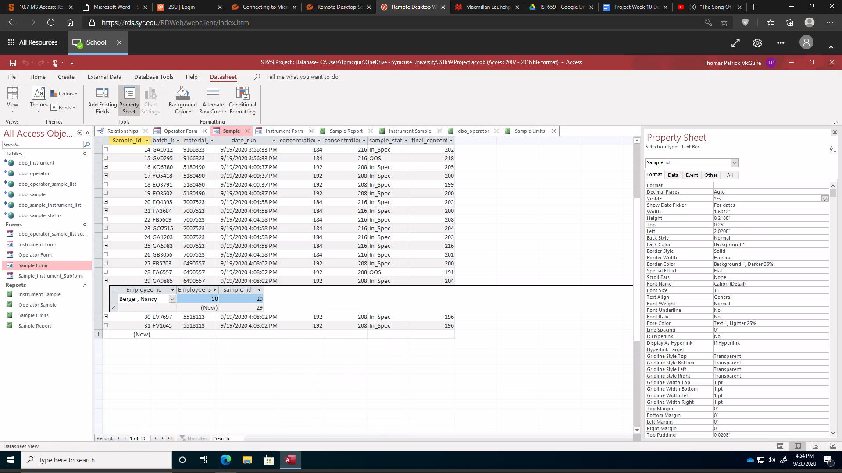

Add Additional Operators:

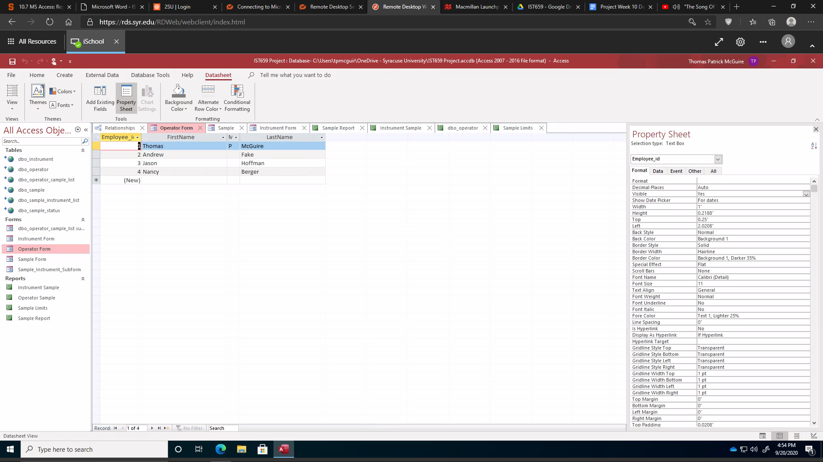

Add Additional Instruments:

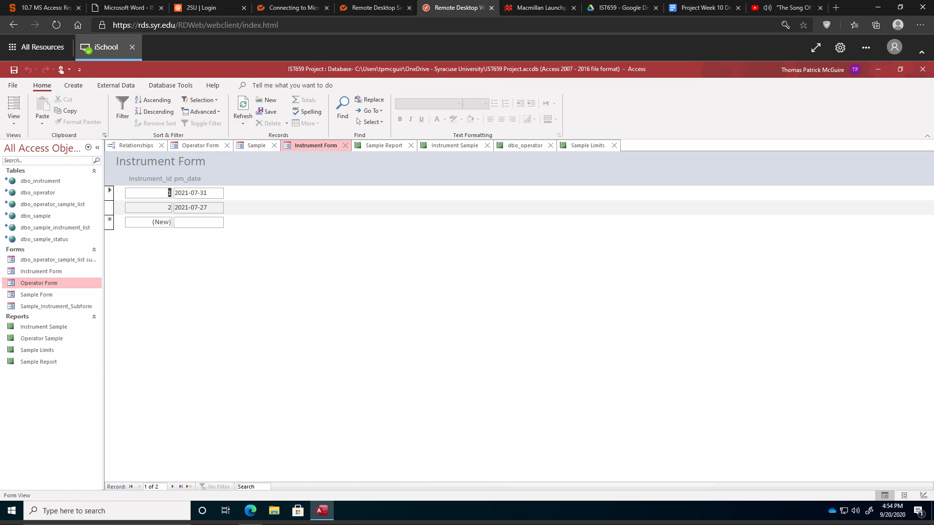

Answering the Data Questions (Part 2):

Which operator is the most consistent in analyzing the concentrations across the instruments?

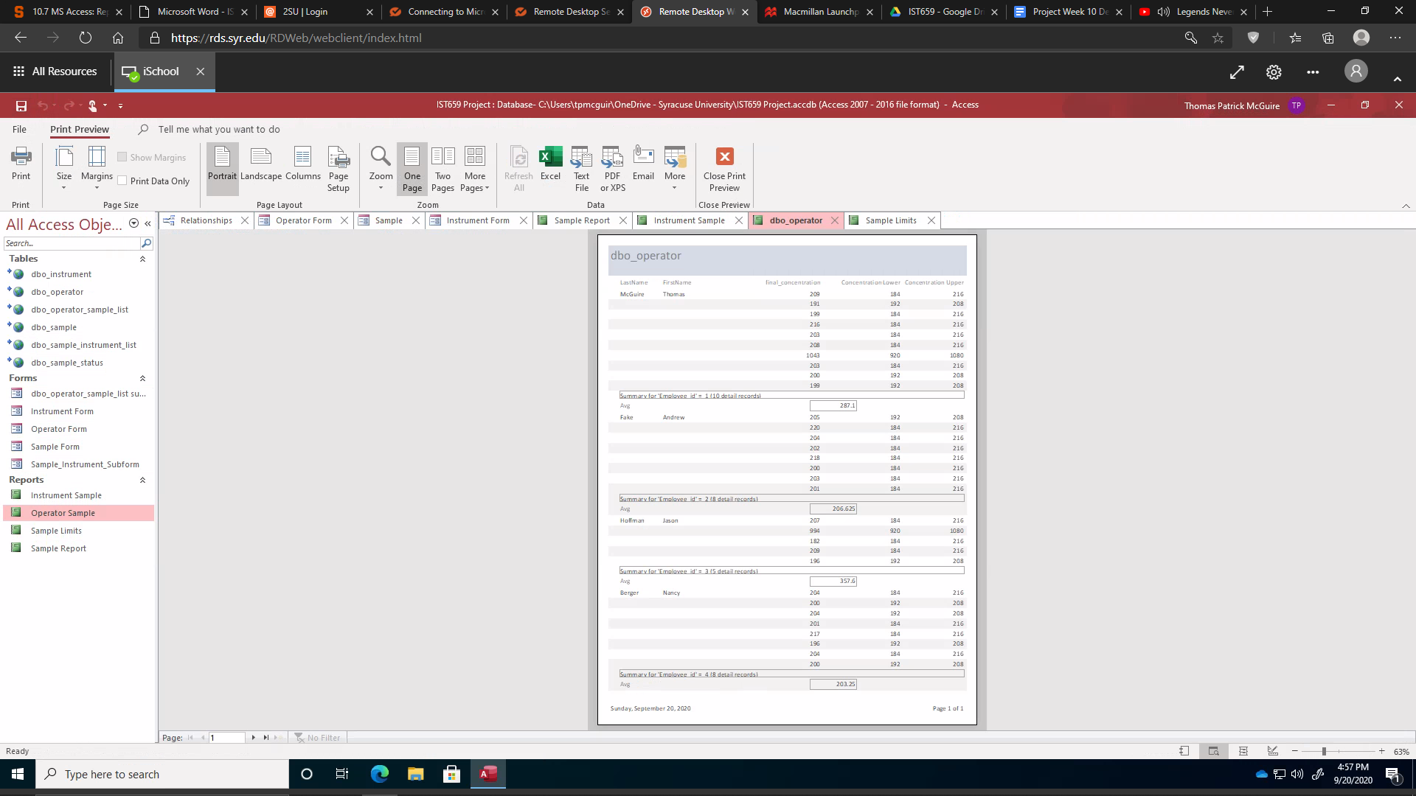

Which products are the closest to the upper and lower limits?

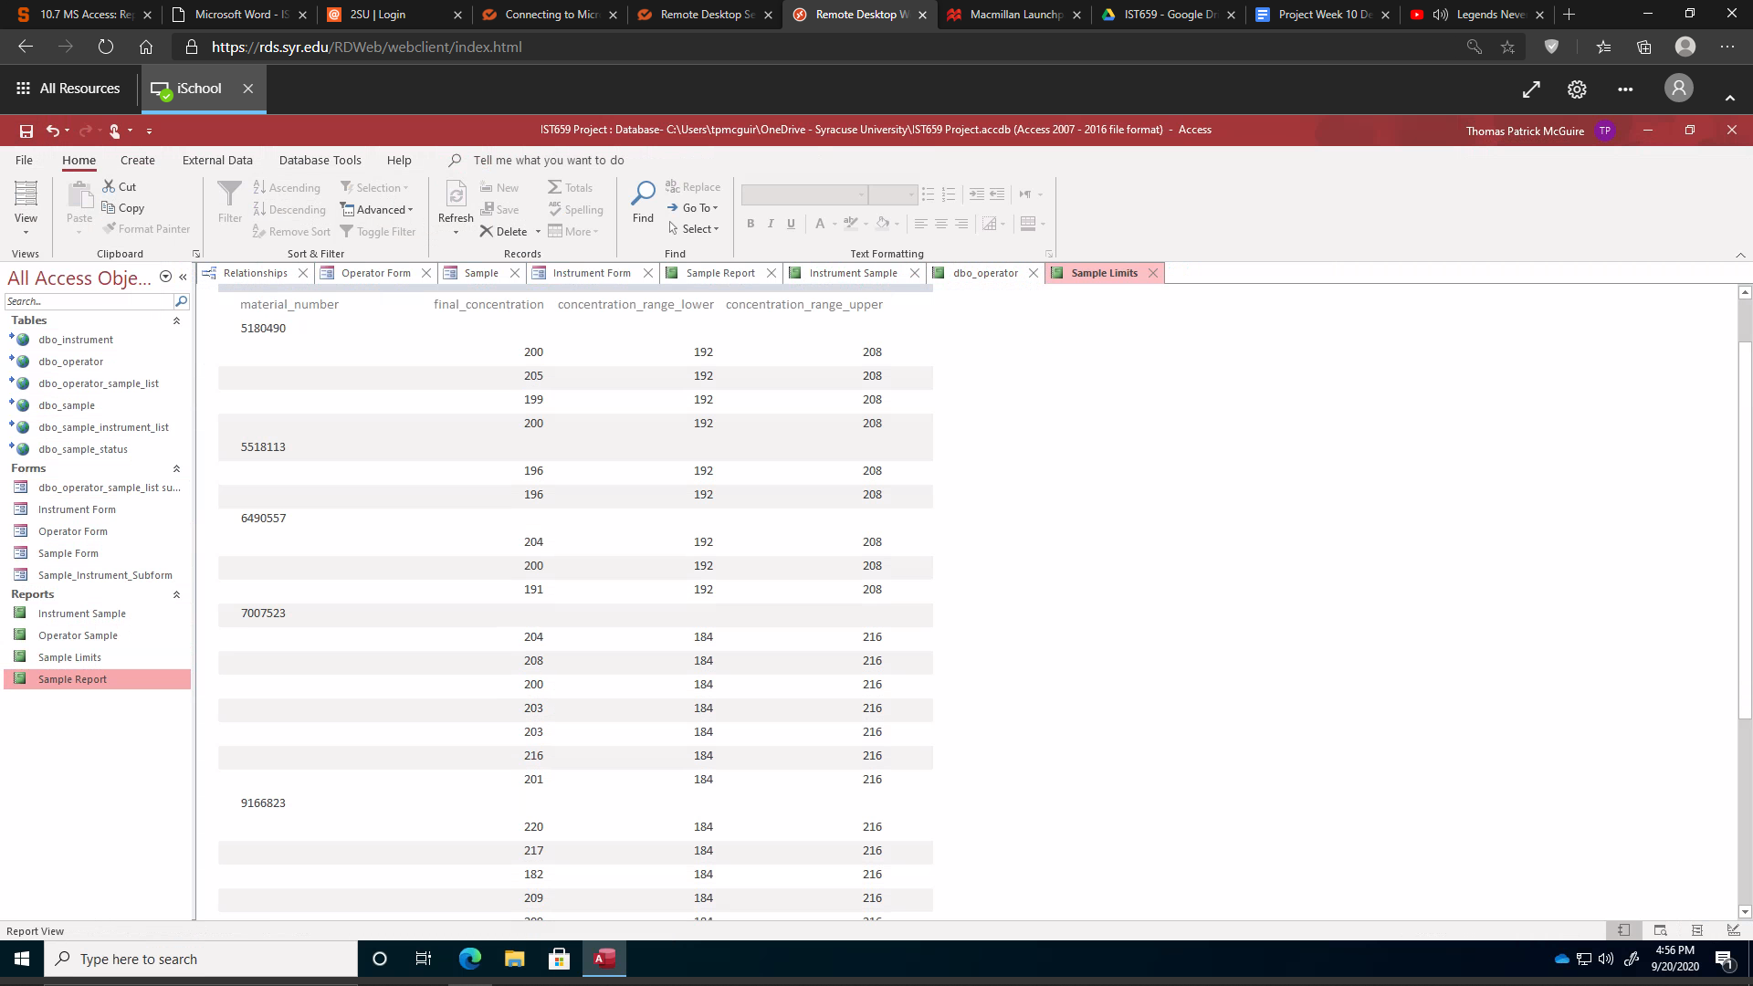

How much variability is there between instruments?

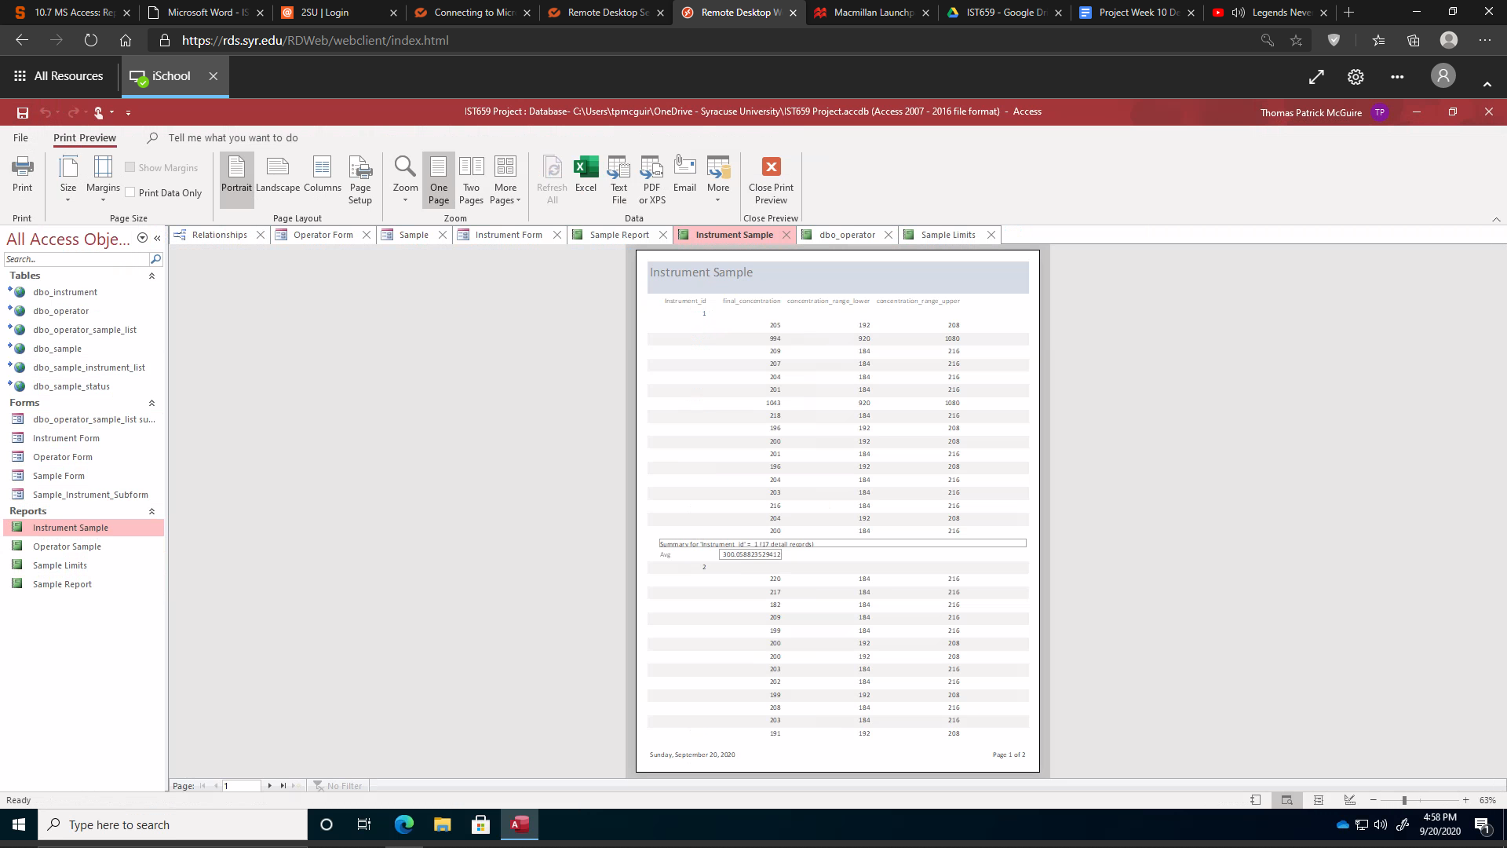

Is there much variability between operators?

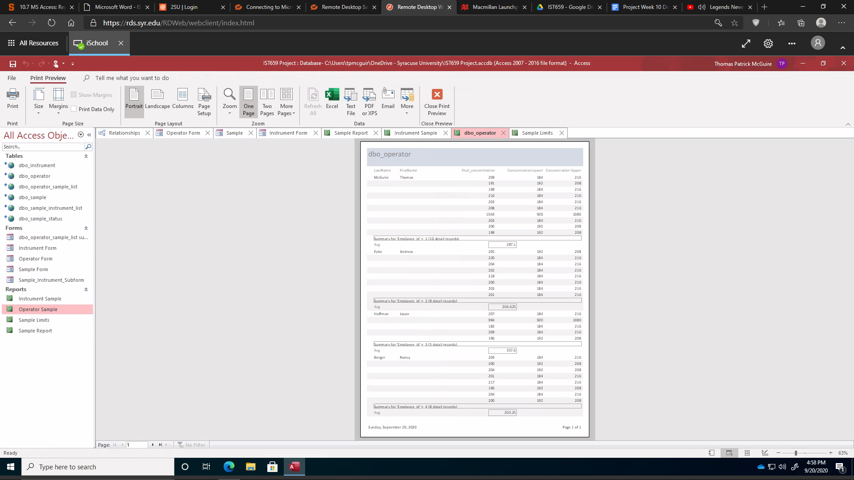

How are the number of samples split between operators?



**Reflection:**

I thought it would be best to split up the results that the instrument spit out and the actual usable result for our paperwork. As I was going through and beginning to code, I realized this was going to be a healthy amount of calculations going on in my code. I knew this could be turned into a stored procedure once I had gotten it all typed out.

One of my main concerns was going to be how to code when samples are Out of Specification (OOS).Because these are major problems, there needs to be a way for the database to know when something is outside it’s specified range. This actually was way easier than I thought with that very simple update statement.

My other biggest struggle in SQL Management Studio was to trying to operate on the temporary columns I created. I think I was trying to do too many calculations and it just did not work out the way I wanted it too. But I believe I got the information across in a decent manner.

As soon as this project was announced, I knew this was going to be the best option for me. It is a needed addition to our business but it just had to be started. I thought it would be a little bit easier to actually implement. But as I was building the conceptual and logical diagrams, I realized there was a lot of information I had not originally considered and if that information was relevant to the database. This is what caused me to alter the database as often as I did. The number of times I had to update my logical diagram as I began to actually build the database was almost silly. It seemed almost every time I had entered anything into my code, I thought of an alternative way to implement my ideas. Some of the information was proprietary and some was just extraneous for this particular scope.

I definitely should have had a materials table where it had the lower and upper concentration limits. This would have been less data entry and therefore been less prone to typos or transcription errors. But I realized this a little bit late into my database creation so if I ever were to do a database similar to this, I would most definitely include a materials table linked to the sample table by material number.

Since I had a little bit of experience using SQL, my greatest challenge during this project was getting Microsoft Access to cooperate with what I was trying to do. It was frustrating trying to get the reports I wanted with the information I wanted.

**Summary:**

In Summary, I created a database detailing the final concentrations of the materials made at my site. I included my fellow operators, the instrumentation that we use and a very small fraction of the samples that have been run in the past month. The database links the operator with the samples they have run and on which instrument those samples were run. There is information on the sample such as the concentration limits, material number, batch id, and if the material can move forward or not. As I had not received feedback, I tried to edit what I thought was weak in the first half of this project.

To answer my data questions, I had to first figure out which table would be best used and then join the appropriate other tables. There are certain metrics I knew I wanted to use from the beginning and others that came to me as I was constructing the database. I struggled to get all the numbers I wanted in some of the reports, both in SQL Server and in Microsoft Access.

I chose to use Microsoft Access because it was the only interface tool I was even remotely familiar with and the only time I even used it was in this class. As I have mentioned before, it was one of the bigger places I struggled, with trying to get the forms and reports the way I wanted them. But I learned and I am proud to turn this in.